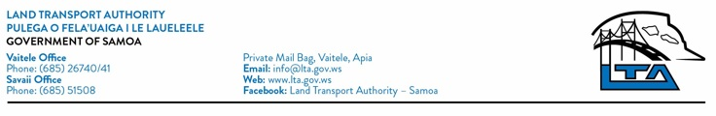
31st March 2021

Re-Tender: LTA Routine Maintenance Contracts FY 2020/21

INVITATION FOR BIDS

The Land Transport Authority (LTA) invites pre-qualified contractors of LTA’s Contractor Registry for Financial Year 2020/21 to tender for the following contracts:

ROUTINE MAINTENANCE
No. | Contracts | No. of Contracts/Zones | Zones
1 | Upolu Road Maintenance Contracts | 2 | 8 & 9
2 | Upolu Drainage Routine Maintenance Contracts | 1 | 8

- Only eligible bidders as specified for each Maintenance Program below may uplift a tender document. Kindly note that the contractor registration fee is only to be paid if the bidder is successfully awarded a contract.

- Tender Documents can be uplifted from Procurement & Programming Division Office at Vaitele Compound from Wednesday, 7th April 2021 at 12:00pm for a non-refundable fee of $250.00/document.

- Pre-bid Meeting – There will be no pre-bid meeting for this tender. However, bidders are encouraged to contact the Authority if needed for more information and/or clarification.

- All bids must be accompanied by a Bid Security in the form and amount specified in the bidding documents.

- Bid submissions must be delivered to the Office of the Secretary to the Tenders Board, Ministry of Finance, Central Bank Building, Level 4, Apia at or before 11:00am on Monday, 19th April 2021. Late bids will not be accepted.
- To obtain further information and clarification, please contact Mr. Toaigaoaloalii Matthew Wendt and/or Mr. Fiu Elisaia Jr Kolia on email matthew.wendt@lta.gov.ws and elisaia.kolia@lta.gov.ws or telephone +685 26740 ext 127 and 132 respectively.

Fa’afetai,

Galumalemana Ta’atialeoiti’iti A. Tutuvanu-Schwalger
CHIEF EXECUTIVE OFFICER
LAND TRANSPORT AUTHORITY

